**Determining Mechanism Favorability using Thermodynamic Property Analysis**

Patsy J. Griffin

Department of Chemistry

St. John’s University

11/14/2019

**Abstract**

The focus of this project was centered around determining which proposed mechanism was most favorable based on thermodynamics for a given dehydration reaction. While two mechanisms have been proposed for the reaction, the group proposing the mechanisms suggests that the second scheme is unlikely because secondary alcohols dehydrate by an E1 mechanism and not an E2 mechanism. The reason for this being that water is not a strong base, which is a requirement for an E2 mechanism. Knowing this information, the goal of this report was to use collected electronic structure calculations to compare the thermodynamics of both mechanisms and then therefore determine which is the most likely in terms of thermodynamics. In order to make a logical argument for which mechanism is more thermodynamically favorable, there were several key variables that needed to be determined for each reaction scheme. The first being the change in internal energy (IE), enthalpy (H), free energy (G) and entropy (S), not only for the overall reaction but also for the individual steps within each reaction scheme. By comparing the delta values of enthalpy and entropy across each step found in Table 1, it was determined that Step C is driven entropically while the remainder of the individual steps as well as the overall reaction are enthalpically driven. Further analysis of the thermodynamic properties of each mechanistic pathway and an overall knowledge of chemistry concluded that proposed mechanism one was in fact less favorable by thermodynamics, contrary to the prediction of the group. The experimental results and other details regarding the analysis can be found in the discussion section.

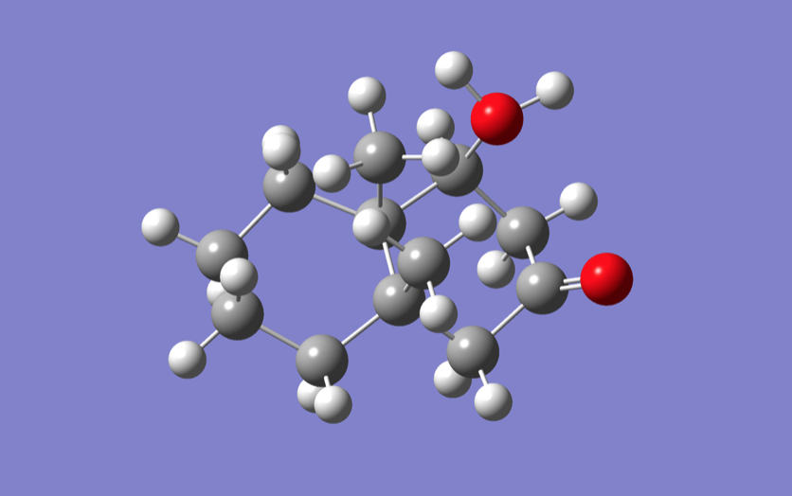

**Introduction**

In chemistry, a dehydration reaction is one in which there is a conversion that involves the loss of water from the reacting molecule or ion [1]. Dehydration reactions are common processes, and are known to be the reverse of a hydration reaction [1]. The focus of this project was centered around determining which proposed mechanism was most favorable based on thermodynamics for a given dehydration reaction. While two mechanisms had been proposed for the reaction, the group proposing the mechanisms suggested that the second scheme is unlikely because secondary alcohols dehydrate by an E1 mechanism (Figure 1) and not an E2 mechanism. The reason for this being that water is not a strong base, which is required for an E2 mechanism. An elimination reaction is a type of organic reaction in which two substituents are removed from a molecule in either a one or two-step mechanism [1]. The one-step mechanism is known as the E2 reaction, and the two-step mechanism is known as the E1 reaction [1].

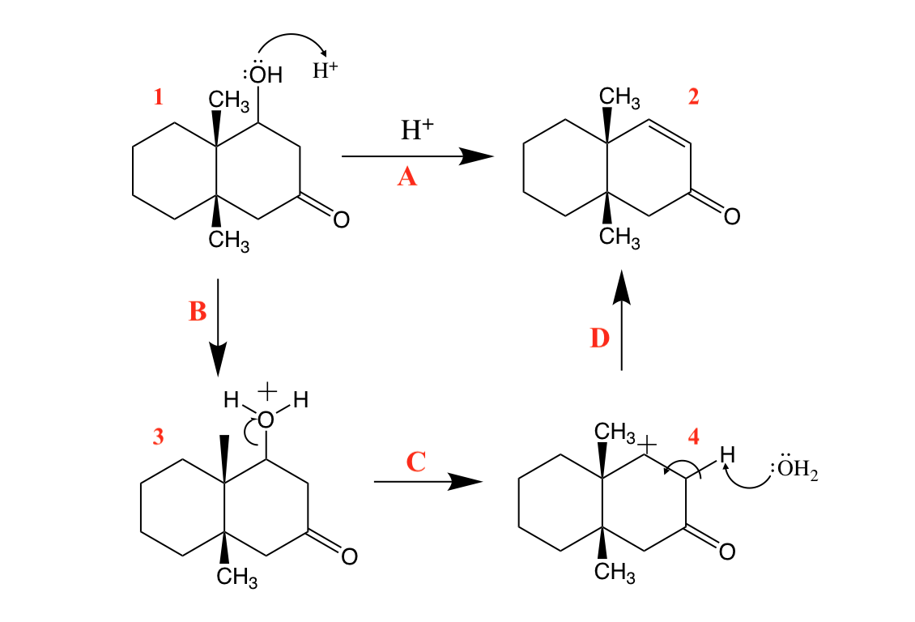

**Figure 1.** Proposed thermodynamically unfavorable mechanism #1 scheme for a given dehydration reaction, said to be most likely to occur by group.

Overall this report aimed to use collected electronic structure calculation data to compare the thermodynamics of both mechanisms and then finally determine which is the most likely in terms of thermodynamics. In order to make a logical argument for which mechanism is more thermodynamically favorable, there were several key variables that needed to be determined for each reaction scheme. The first being the change in internal energy (IE), enthalpy (H), free energy (G) and entropy (S) not only for the overall reaction but also for the individual steps within each reaction scheme. Using the calculated values of each variable previously mentioned, whether the overall reaction and the individual steps were being driven by entropy or enthalpy was able to be determined. The last piece of this project to be considered was to finally conclude which of the two proposed mechanisms is more thermodynamically favorable. To make an argument that mechanism #2 is the more favorable of the two which were proposed, I will use an adaptation of the Arrhenius equation which gives, $k$ ∝ $exp\frac{-∆G}{RT} [7]$.

**Computational Details**

The projects goal was to be executed by using collected electronic structure calculations to compare the thermodynamics of both proposed mechanisms in order to make a determination of which is the most favorable in terms of thermodynamics. The calculations detailed in the previous paragraph were executed using an advanced computer software program known as GaussView (we used Version 16). GaussView's Builder palette makes constructing molecules simple and fast. Having both of the mechanism pathways defined at the start of the project, it was clear exactly which molecules then had to be built within the program. Each given molecule was built by simply selecting the desired ring or atom from GaussView's Rings palette and element table, then by clicking on an existing atom to add to the overall structure. Once all given molecules were built within the program (therefore an input file for each was created), the next step involved setting up calculation parameters to be able to submit calculations. For the purposes of this report and the thermodynamic properties of interest, three different calculations jobs were submitted for each molecule present within the mechanisms: geometry optimization, energy, and lastly optimization and frequency paired together.

The first step in submitting a calculation job within GaussView was to choose the job type, which in this case was any of the three just mentioned. Once the job type was selected, next the program prompts the user to choose both a method and basis set. For all molecules, the method for optimization calculations was the Hartree-Fock method with the lowest basis set of 3-21G [3]. For submitting calculations for energy, a more in-depth basis set was needed in order to handle the larger output of this type. To accomplish this there was a gradual build up (in order to avoid the failed convergence of calculation) in basis set from 3-21G to in the final stages 6-311G (along with specified 2d, 2p) [4]. Besides adjusting the basis set the overall method was also changed in order to accommodate energy calculations, from Hartree-Fock to the density functional theory (commonly abbreviated as DFT). Another parameter set for both the energy and optimization frequency calculations (besides using DFT) was the level of theory, which in the case of the project was B3LYP.

When a Gaussian calculation job is finished running, one will receive a message in GaussView which will allow for the viewing of an output file. For this project it was the “.chk” file of the optimization frequency calculation which gave thermodynamic data which was then manipulated for analysis purposes. The same process detailed above was repeated across all given molecules. More in depth information regarding GaussView and how it was implemented for this project including details about basis sets, job types, and methods can be found in the supplemental information section.

**Results and Discussion**

The focus of this project was centered around determining which proposed mechanism was most favorable based on thermodynamics for a given dehydration reaction. While two mechanisms have been proposed for the reaction, the group proposing the mechanisms suggests that the second scheme is unlikely because secondary alcohols dehydrate by an E1 mechanism and not an E2 mechanism. This led to the goal of this report being to use collected electronic structure calculations to compare the thermodynamics of both mechanisms and then therefore determine which is the most likely in terms of thermodynamics. In order to make a logical argument for which mechanism is more thermodynamically favorable, there were several key variables that needed to be determined for each reaction scheme. The first being the change in internal energy, enthalpy, free energy, and entropy not only for the overall reaction but also for the individual steps within each reaction scheme. Using the calculated values of each variable previously mentioned, whether the overall reaction and the individual steps are being driven by entropy or enthalpy was then able to be determined.

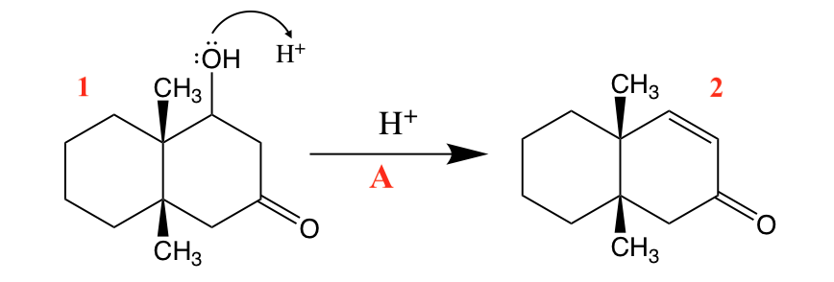

**Figure 2.** Overall reaction scheme for the given dehydration reaction.

As mentioned above, GaussView allowed for the determination of internal energy, enthalpy, free energy, and entropy not only for the overall reaction, but also for the individual steps within each reaction scheme. By then using these calculated values of each variable, the overall total changes in these variables were then able to be calculated. To calculate the change in free energy during each step, the free energy of all the products as well as the reactants for that step had to all be taken into account (Equation 1). This means that in order to have the calculated value of ∆G= -1.215484933 kcal/mol for Step E denoted in Figure 3 below, we had to add together the individual values of free energy for Molecule 1 and H3O+ and subtract that sum from the sum of the free energies of Molecule 3 and water (Equation 2).

(1) $∆G= Σ {∆G}_{products }- {∆G}_{reactants }$

(2) *Step E: $Molecule 1+ H_{3}O^{+}→Molecule 3+ H_{2}O$*

$∆G_{E}={[(∆G}_{Molecule 3}+{∆G}_{H_{2}O})- {(∆G}_{Molecule 1}+{∆G}_{H_{3}O^{+}})$]

$$∆G_{E}= -1.215484933 kcal/mol$$

By repeating the same calculation scheme, except using the individual values for the molecules of which the step possessed, the change in free energy was able to be calculated for all steps involved in both mechanisms (even the overall reaction itself). The change in internal energy, enthalpy, and entropy for the individual steps within each mechanism was able to be calculated in this manner as well using their respective individual values. These final values are compiled within Table 1 and step labeling can be cross referenced with Figures 1, 2, and 3. As you can see within Table 1, the values for all variables for Step A_1, Step A_2 and Step A are exactly the same. This is correct by way of that they are in essence relating to the overall product step which is the same across both mechanisms, being that it is relaying the same dehydration reaction. While you could repeat the same process as detailed above taking into account the individual values for products and the reactants, for Step A as a sanity check you could have also taken the sum of the delta values for the steps within that mechanism (Equation 3).

(3) $∆G_{A_1}= Σ {∆G}_{products }- {∆G}_{reactants }$

$$∆G_{A_{1}}= Σ {∆G}_{products }- {∆G}_{reactants }=∆G_{B}+∆G_{C}+∆G_{D}$$

$∆G_{A_{1}}=∆G_{B}+∆G_{C}+∆G_{D}=-1.215+(-4.780)+58.851 \frac{kcal}{mol}$

$$∆G_{A_{1}}=52.855 \frac{kcal}{mol}=∆G_{A_{2}}= ∆G_{A}$$

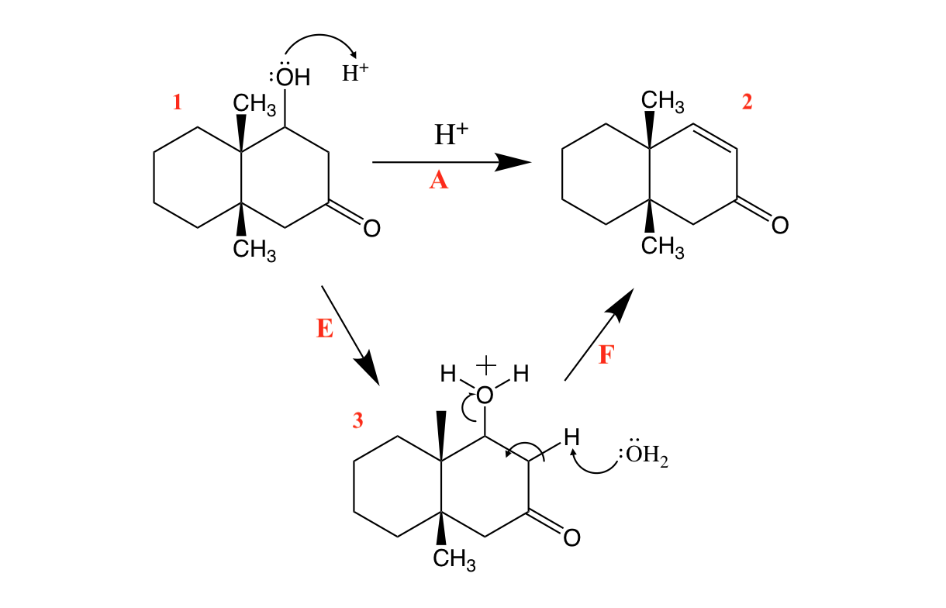

**Figure 3.** Proposed thermodynamically favorable mechanism #2 scheme for a given dehydration reaction.

Once all of the calculations were performed the central questions of this project were able to be answered, that is if whether the overall reaction and the individual steps are being driven by entropy or enthalpy. To answer this question, the Gibbs free energy equation which is given by G = H − TS, where H is the enthalpy, T is the absolute temperature, and S is the entropy had to be employed. By definition, Gibbs Free Energy is used to determine whether a reaction is favored or disfavored. If ΔG < 0, then products are favored at equilibrium, and the forward reaction is thermodynamically favored. Conversely, if ΔG > 0, then reactants are favored at equilibrium, and the forward reaction is thermodynamically disfavored. A thermodynamically favored reaction (ΔG < 0) is sometimes referred to as "spontaneous". However, this does not necessarily mean that the reaction will proceed at a detectable rate because under certain conditions a present high kinetic barrier prevents a reaction from actually taking place.

Reactions are said to be driven by enthalpy when a very exothermic reaction (negative ΔH) overcomes a decrease in entropy. Comparatively, reactions are said to be driven by entropy when an endothermic reaction occurs because of a highly positive ΔS. Due to the fact that thermodynamic data was previously calculated, in order to determine whether or not a given step or the overall reaction was entropically driven, it came down to if there was a larger observable change in entropy versus enthalpy (Equation 4). By comparing the delta values of enthalpy and entropy across each step found in Table 1, it was determined that Step C is driven entropically while the remainder of the individual steps as well as the overall reaction are enthalpically driven.

(4) $∆G= ∆H-T∆S$

$$∆H>T∆S →enthalpically driven$$

$$∆H<T∆S →entropically driven$$

*Step D: $∆H= 58.387 \frac{kcal}{mol}$*  *, $T∆S= -0.464 \frac{kcal}{mol}$*

*Step D: $∆H> T∆S→ enthalpically driven$*

*Overall Reaction: $∆H= 63.440 \frac{kcal}{mol}$*  *, $T∆S= 10.585 \frac{kcal}{mol}$*

*Overall Reaction: $∆H> T∆S→ enthalpically driven$*

**Table 1.** Calculated thermodynamic data of change in internal energy, enthalpy, free energy, and entropy for all individual steps and the overall reaction for a given dehydration reaction.

|  |  |  |  |  |  |  |  |  |  |
| --- | --- | --- | --- | --- | --- | --- | --- | --- | --- |
|  | Step A_1 | Step A_2 | Step B | Step C | Step D | Step E | Step F | Overall Rxn | Units |
| $$∆G$$ | 52.855 | 52.855 | -1.215 | -4.780 | 58.851 | -1.215 | 54.071 | 52.855 | **kcal/mol** |
| $$∆IE$$ | 62.848 | 62.848 | -2.184 | 6.645 | 58.387 | -2.184 | 65.032 | 62.848 | **kcal/mol** |
| $$∆H$$ | 63.440 | 63.440 | -2.184 | 7.237 | 58.387 | -2.184 | 65.624 | 63.440 | **kcal/mol** |
| $$∆S$$ | 35.503 | 35.503 | -3.248 | 40.306 | -1.555 | -3.248 | 38.751 | 35.503 | **kcal/mol-K** |
| $$T∆S$$ | 10.585 | 10.585 | -0.968 | 12.017 | -0.464 | -0.968 | 11.554 | 10.585 | **kcal/mol** |

The last piece of this project to be considered was to finally conclude which of the two proposed mechanisms is more thermodynamically favorable. To make an argument that mechanism #2 is the more favorable of the two I will use an adaptation of the Arrhenius equation which gives, $k$ ∝ $exp\frac{-∆G}{RT} [7]$. This equation shows that for larger values of ∆G the rate constant will be smaller and conversely for smaller values. For this interpretation of the equation, it is said that the change in Gibbs free energy is closely related to the energy of activation. The Arrhenius equation also mathematically expresses the relationship previously established: as activation energy term Ea increases, the rate constant k decreases and therefore the rate of reaction decreases. In mechanism #1, there are two steps which have extremely large differences in values for ∆G therefore leading to small rate constants and a decreased rate of reaction. This means that this reaction mechanism will be slow and probably unlikely in terms of kinetics. The same principal can be applied when taking into account what the free energy landscape would look like for each mechanism (Figure 4 and 5). Between the two steps within mechanism #1, the energy barrier is so high that from our knowledge of general chemistry it will be less favorable to overcome such a large gap. Also, between the four steps which make up the overall reaction there is not a visible “settle” point. Although it is evident that there is one larger gap, and two smaller ones it is still not as smooth a transition leading into the eventual product formation as in the other proposed mechanism. For this reason, it is more favorable and energetically reasonable for this dehydration reaction to process in fewer steps as it does in mechanism #2 (Figure 3). The free energy landscape of mechanism #2 visually shows that there is a more consistent building of energy that increases within the first step, then settles between the second step and the last step. This line of reasoning lends to the conclusion that mechanism #2 is the best based on thermodynamics.

As previously stated, the outcome using thermodynamic property analysis was that the second mechanism is the most favorable. This was contrary to what the first group had proposed in that they predicted the first mechanism was to be more likely due to the fact secondary alcohols dehydrate by an E1 mechanism and not an E2 mechanism. The reason for this being that water is not a strong base, which is required for an E2 mechanism. Several factors could have played a role in yielding different results using computational means than what is expected to happen in the real world. The first probable explanation is that a solvent would be present in the real world experiment, but for the purposes of computational calculations this wasn’t included. When water is present, there would obviously be more interactions including hydrogen bonding which would then change the calculated results. Another source of significant errors can present themselves in ab initio models comprising many electrons, due to the computational cost of full relativistic-inclusive methods. This complicates the study of molecules interacting with high atomic mass unit atoms, such as transitional metals and their catalytic properties. Other examples of three main sources of inaccuracy could be stemming from: the modelling, the data, and the experimentation. Especially in the case of this project, a beginner is likely to poorly model molecules within GaussView and simulation setup is improved only upon extensive experience.

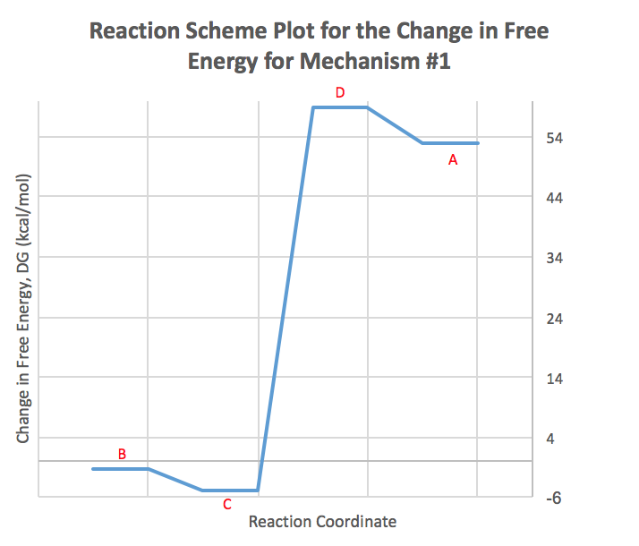

**Figure 4.** Free energy landscape for the thermodynamically unfavorable mechanism #1 for a given dehydration reaction.

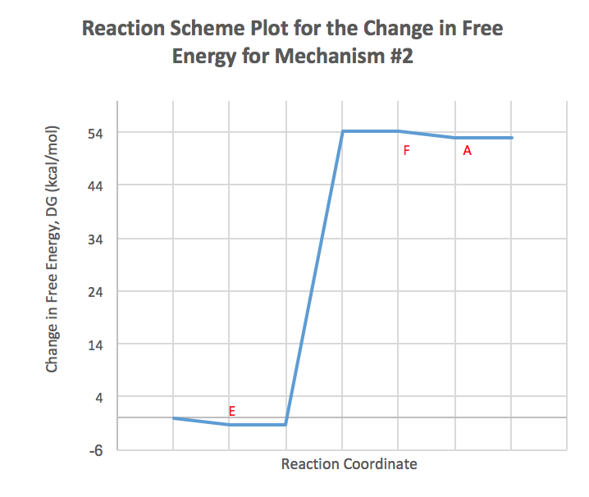

**Figure 5.** Free energy landscape for the thermodynamically favorable mechanism #2 for a given dehydration reaction.

**Conclusion**

This report aimed to use collected electronic structure calculations to compare the thermodynamics of two proposed mechanisms for a dehydration reaction and determine which is the most likely in terms of thermodynamics. One of the central questions answered was whether or not a given step or the overall reaction was entropically or enthalpically driven. This determination was made by accessing if there was a larger observable change in entropy versus enthalpy (Equation 4). By comparing the delta values of enthalpy and entropy across each step found in Table 1, it was determined that Step C is driven entropically while the remainder of the individual steps as well as the overall reaction are enthalpically driven. The last piece of this project to be considered was to finally conclude which of the two proposed mechanisms is more thermodynamically favorable. To make an argument that mechanism #1 is the more favorable of the two I will use an adaptation of the Arrhenius equation which gives, $k$ ∝ $exp\frac{-∆G}{RT} [7]$. Between the two steps within mechanism #1, the energy barrier is so high that from our knowledge of general chemistry it will be less favorable to overcome such a large gap. For this reason, it is more favorable and energetically reasonable for this dehydration reaction to process in several intermediate steps as it does in mechanism #2.

**Bibliography**

[1] Reddy, Sudharshan, et al. “E1 Vs E2: Comparing the E1 and E2 Reactions.” Master Organic Chemistry, MASTER ORGANIC CHEMISTRY LLC, 27 Sept. 2019, www.masterorganicchemistry.com/2012/10/10/comparing-the-e1-and-e2-reactions/.

[2] GaussView, Version 6, Dennington, Roy; Keith, Todd A.; Millam, John M. Semichem Inc., Shawnee Mission, KS, 2016.

[3] J. S. Binkley, J. A. Pople, and W. J. Hehre, “Self-Consistent Molecular Orbital Methods. 21. Small Split-Valence Basis Sets for First-Row Elements,” J. Am. Chem. Soc., 102 (1980) 939-47. DOI: 10.1021/ja00523a008

[4] A. D. McLean and G. S. Chandler, “Contracted Gaussian-basis sets for molecular calculations. 1. 2nd row atoms, Z=11-18,” J. Chem. Phys., 72 (1980) 5639-48. DOI: 10.1063/1.438980

[5] P. Hohenberg and W. Kohn, “Inhomogeneous Electron Gas,” Phys. Rev., 136 (1964) B864-B71. DOI: 10.1103/PhysRev.136.B864

[6] Chengteh Lee; Weitao Yang; Robert G. Parr (1988). "Development of the Colle-Salvetti correlation-energy formula into a functional of the electron density". Phys. Rev. B. 37 (2): 785–789. Bibcode:1988PhRvB..37..785L. doi:10.1103/PhysRevB.37.785.

[7] Arrhenius, S. A. (1889). "Über die Dissociationswärme und den Einfluß der Temperatur auf den Dissociationsgrad der Elektrolyte" (PDF). Z. Phys. Chem. 4: 96–116. doi:10.1515/zpch-1889-0408.

**Supplemental Information**

The projects goal was to be executed by using collected electronic structure calculations to compare the thermodynamics of both mechanisms and then therefore determine which is the most likely in terms of thermodynamics.

1. ***What is GaussView?***

The calculations detailed in the previous paragraph were executed using an advanced computer software program known as GaussView. GaussView is an affordable, full-featured graphical user interface for Gaussian 98 [2]. With GaussView you can construct molecular systems of interest quickly and efficiently using its molecule building facility. You can also set up and run Gaussian calculations right from the interface, and monitor their progress as they run [1]. When a calculation has completed, you can use GaussView to examine a variety of results graphically via its advanced visualization facilities [2].

1. ***Building with GaussView***

GaussView's Builder palette makes constructing molecules simple and fast. Having both of the mechanism pathways defined at the start of the project it was clear exactly which molecules then had to be built within the program. Instead of typing all the coordinates, theory, basis set, etc., we can use GaussView. Each given molecule was built by simply selecting the desired ring or atom from GaussView's Rings palette and element table, then clicking on an existing atom to add to the overall structure. This process was repeated atom by atom until the framework for each molecule was completed. A helpful tool that GaussView provides is the brush, which allows one to “clean up” and readily optimize the structure of a built molecule before running any calculation. Other properties such as bond angles, bond lengths, and overall atom orientation can be readily adjusted via the Builder palette. GaussView generates the Gaussian input file, and can run Gaussian without ever returning to the Unix prompt [2].

1. ***Submitting Calculations via GaussView***

Once all given molecules were built within the program and therefore an input file for each

was created, the next step involved setting up calculation parameters to be able to submit calculations. GaussView offers various different types of calculations within the program including, single point energy and properties (electron density, dipole moment, etc.), geometry optimization, frequency, and reaction path following [2]. For the purposes of this report and the thermodynamic properties of interest, three different calculations jobs were submitted for each molecule present within the mechanisms: geometry optimization, energy, and lastly optimization and frequency paired together.

The first step in submitting a calculation job within GaussView was to choose the job type, which in this case was any of the three just mentioned. Once the job type was selected, next the program prompts the user to choose both a method and basis set. For all molecules, the method for optimization calculations was the Hartree-Fock method with the lowest basis set of 3-21G [3]. A basis set in theoretical and computational chemistry is a set of functions (called basis functions) that is used to represent the electronic wave function in the Hartree-Fock method or density-functional theory in order to turn the partial differential equations of the model into algebraic equations suitable for efficient implementation on a computer [2]. The use of basis sets is to express molecular orbitals as linear combinations of the basis functions [2]. In addition to selecting those two parameters, the overall charge of each molecule and the solvent of which was present (which in this case was always water) also had to be selected before finally submitting the job.

For submitting calculations for energy, a more in-depth basis set was needed in order to handle the larger output of this type. To accomplish this there was a gradual build up (in order to avoid the failed convergence of calculation) in basis set from 3-21G to in the final stages 6311G [4]. Besides adjusting the basis set the overall method was also changed in order to accommodate energy calculations from the Hartree-Fock to density functional theory (commonly abbreviated as DFT). Density functional theory (DFT) is a quantum mechanical theory used in physics and chemistry to investigate the electronic structure (principally the ground state) of many-body systems, in particular atoms, molecules, and the condensed phases [5]. These multiple determinant calculations require very large basis sets due to the poor convergence of the correlation energy when the inter-electronic distance becomes very small [5]. Another parameter set for both the energy and optimization frequency calculations (besides using DFT) was the level of theory which the case of the project was B3LYP. Hybrid functionals such as B3LYP are a class of approximations to the exchange-correlation energy functional in density functional theory (DFT) that incorporate a portion of exact exchange from HF theory with the rest of the exchange–correlation energy from other sources [6]. Overall, B3LYP provides a simple scheme for improving the calculation of many molecular properties, such as [atomization energies](https://en.wikipedia.org/wiki/Enthalpy_of_atomization), [bond lengths](https://en.wikipedia.org/wiki/Bond_length) and [vibration frequencies](https://en.wikipedia.org/wiki/Infrared_spectroscopy), which tend to be poorly described with simple "ab initio" functionals [6].

1. ***Output Visualization***

When Gaussian is finished running, you will receive a message in GaussView. When it is complete, GaussView will inform the use and allow to view an output file. This output file which will most likely be a “.chk” file will summarize all the variables that had been calculated. For this project it was the “.chk” file of the optimization frequency calculation which gave thermodynamic data which was then manipulated to for analysis purposes. The same process detailed above was repeated across all given molecules.

**References**

[1] Reddy, Sudharshan, et al. “E1 Vs E2: Comparing the E1 and E2 Reactions.” Master Organic Chemistry, MASTER ORGANIC CHEMISTRY LLC, 27 Sept. 2019, www.masterorganicchemistry.com/2012/10/10/comparing-the-e1-and-e2-reactions/.

[2] GaussView, Version 6, Dennington, Roy; Keith, Todd A.; Millam, John M. Semichem Inc., Shawnee Mission, KS, 2016.

[3] J. S. Binkley, J. A. Pople, and W. J. Hehre, “Self-Consistent Molecular Orbital Methods. 21. Small Split-Valence Basis Sets for First-Row Elements,” J. Am. Chem. Soc., 102 (1980) 939-47. DOI: 10.1021/ja00523a008

[4] A. D. McLean and G. S. Chandler, “Contracted Gaussian-basis sets for molecular calculations. 1. 2nd row atoms, Z=11-18,” J. Chem. Phys., 72 (1980) 5639-48. DOI: 10.1063/1.438980

[5] P. Hohenberg and W. Kohn, “Inhomogeneous Electron Gas,” Phys. Rev., 136 (1964) B864-B71. DOI: 10.1103/PhysRev.136.B864

[6] Chengteh Lee; Weitao Yang; Robert G. Parr (1988). "Development of the Colle-Salvetti correlation-energy formula into a functional of the electron density". Phys. Rev. B. 37 (2): 785–789. Bibcode:1988PhRvB..37..785L. doi:10.1103/PhysRevB.37.785.